**"Guru99 Bank" project**

**DAY 1**

Here is a link to the AUT - [http://www.demo.guru99.com/V4/](http://clicks.aweber.com/y/ct/?l=883Cz&m=3tZajL7VP9FEjy9&b=prPbHMlViYiMOepFCRUZDw)

The following test case needs to be automated -

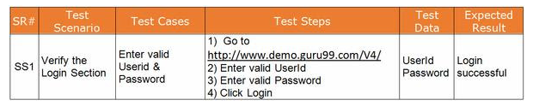

The client has requested you to use WebDriver (Firefox Driver) for the project. Go ahead and record the script in Webdriver.

***************************************************************************************************************************************

**DAY 2**

There is a major flaw in the test case we created. There is no verification step.The script is no-good if it cannot produce Pass & Fail Status. Go ahead and modify the script

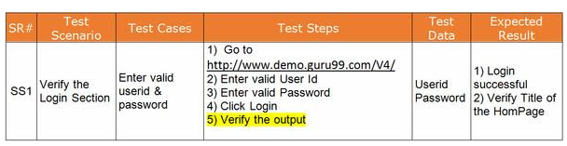

|  |
| --- |
|  |

But WAIT!

There is another major flaw. **The script is a rookie script & in not production ready**.

Here is how you can make the script production ready

1. The code to setup and launch WebDriver (Firefox) should be improved to include Location   Firefox.exe    and a Firefox Profile must be created.
2. The amount of time the driver should wait when searching for a GUI element should be specified
3. The code to setup and launch Firefox should be created as a separate method.
4. All script initialization parameters like Location of Firefox , Base URL, User Name , Password etc should be stored in separate file say Util.java.  This helps in easy maintenance of script

Go ahead and code the script.

***************************************************************************************************************************************

**DAY 3**

The client has enhanced the test scenario to include more test cases

|  |
| --- |
|  |

One approach to automate this is to record separate script for all the above test cases. But this defeats the very purpose of automation.

The best technique to automate the above test suite  is to parametrize the script.

The most famous tool store data for parametrization is MS Excel.

Go ahead and create a script to read test-data from an Excel and execute Webdriver test cases.